Fetal membranes
- Chorion
- Yolk sac
- Allantois
- Amnion
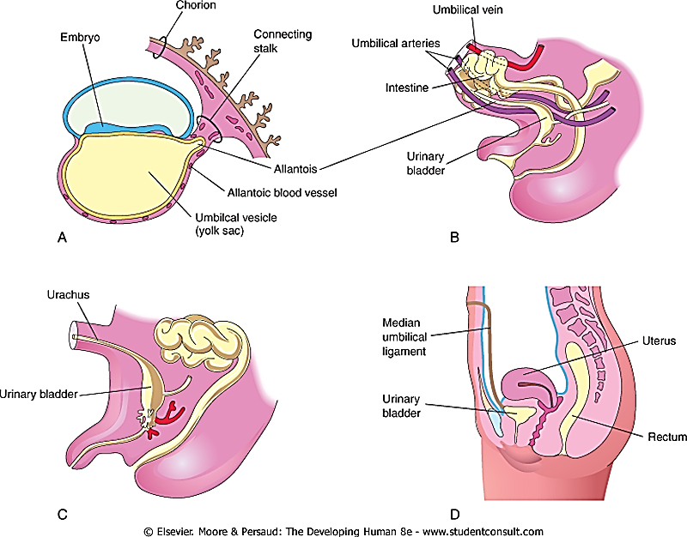

Chorion
Consists of developing trophoblast and extraembryonic mesothelium
Cellularity:
Inner cellular layer – reticular layer of fibroblasts and Hofbauer cells
The outer layer – cytotrophoblast of 3 to 10 cells deep, resting on a pseudo-basement membrane

Yolk sac
A cavity lined with hypoblast, which is continuous with the developing endoderm from the primitive streak.

Inner cells of the yolk sac – synthesize several serum proteins in common with the fetal liver, such as alpha-fetoprotein (AFP), alpha-1-antitrypsin, albumin, pre-albumin and transferrin.
The secondary yolk sac plays a major role in the early embryonic development of all mammals

Secondary yolk sac is the first structure that can be detected ultrasonographically within the chorionic cavity

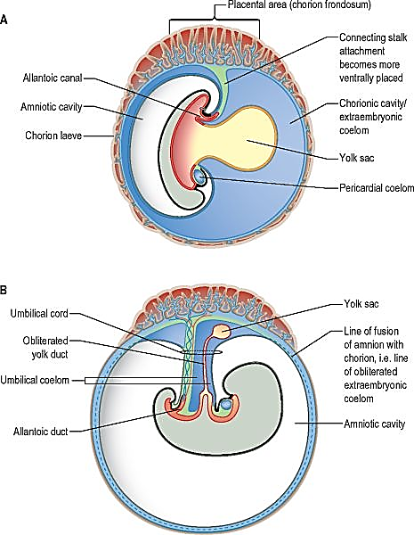

After week 9 the cellular components of the wall of the secondary yolk sac start to degenerate, and their function is subsumed into exchanges at the placental chorionic plate. With embryonic development of the midgut, the connection of the yolk sac to the embryo becomes attenuated to a slender and elongated vitelline intestinal duct. Both the yolk sac and its duct remain within the extraembryonic coelom (chorionic cavity) throughout gestation, located between the amnion and chorion as they fuse, near the placental attachment of the umbilical cord

Allantois
A canalised endodermal outgrowth from the dorsocaudal part of the yolk sac into the mesenchyme of the connecting stalk
The allantois is a site of angiogenesis, giving rise to the umbilical vessels which connect to the placental circulation.
The extraembryonic mesenchyme around the allantois forms the connecting stalk, which is later incorporated into the umbilical cord

Amnion (chorio-amnion)
Consists of amniogenic cells derived from edges of epiblast of embryonic disc. These cells outline the amniotic cavity. This cavity expands until it touches chorion – to form chorio-amnion. The amniotic membrane extends along the connecting stalk and forms the outer covering of the umbilical cord.

Human amniotic epithelial cells are thought to be pluripotent because they arise so early from the conceptus

Amniotic Fluid
- An aqueous solution in which undissolved material (desquamated fetal epithelial cells) is suspended
- Fetal urine enters amnion

Significance of amniotic fluid
- The embryo, suspended in amniotic fluid by the umbilical cord, floats freely
- Permits symmetric external growth of the embryo and fetus
- Acts as a barrier to infection
- Permits normal fetal lung development
- Prevents adherence of the amnion to the embryo and fetus
- Cushions the embryo and fetus against injuries by distributing impacts the mother receives
- Helps control the embryo's body temperature
- Enables the fetus to move freely

Clinical relevance
- Oligohydramnios
  - <500 mL, often from renal agenesis or premature rupture of membranes.
  - Risks pulmonary hypoplasia/compression deformities
- Polyhydramnios
  - >2,000 mL, e.g., diabetes/swallowing defects) increases preterm labor
  - Monitored via USG (AFI or SDP).
- Amniocentesis
  - Fluid sampling (15-20 weeks) for karyotyping, CMA, or NGS detects aneuploidies (e.g., trisomy 21) with 99% accuracy; fetal cells shed into fluid
- Fetal lung maturity
  - Lecithin/sphingomyelin (L/S) ratio >2:1 or lamellar body count >50,000/μL indicates RDS risk low
  - Guides steroid timing in preterm cases.

